Creating Images to Visualize Data
Objective
The purpose of this exercise is to create images from quantitative and categorical data. In this section you will have the opportunity to:
- Learn about the matrix data structure
- Use the apply command to execute a function over all rows and columns of a matrix
- Use a matrix to store the values of quantitative and categorical variables
- Create an image from pixel intensities derived from those values

Before you start, you should:
- Read Sections 3.1 through 3.23 in Matloff

Data Format
To create our image, first we need to store the data that will become the image. The data structure we will use is a matrix, which stores a collection of rows and columns of data. (Picture the data you might find in an Excel spreadsheet, organized in terms of rows and columns.) You use a matrix when all of your columns contain data that is of the same type. In a data frame, you might have several columns that contain numeric data, another column that contains factors, and yet another that contains character strings. You can only store one type of data in your matrix: all of the columns have to contain numbers, or all of the columns have to contain character strings... but you can't mix them.
Let's familiarize ourselves with the matrix by creating one and manipulating it just a little. First, you have to set up the variable that contains the matrix like this:
mm <- matrix(initialization_value, number_of_rows, number_of_columns)
The initialization value is the actual value that you want to prepopulate the matrix with, so for example, if you want a matrix with 12 rows and 12 columns and you want to fill all of the cells in with the value 888, you would do this:
mm <- matrix(888,12,12)
You can check to see what happened by typing mm which should show you something like this:
> mm
[,1] [,2] [,3] [,4] [,5] [,6] [,7] [,8] [,9] [,10] [,11] [,12]
[1,] 888 888 888 888 888 888 888 888 888 888 888 888
[2,] 888 888 888 888 888 888 888 888 888 888 888 888
[3,] 888 888 888 888 888 888 888 888 888 888 888 888
[4,] 888 888 888 888 888 888 888 888 888 888 888 888
[5,] 888 888 888 888 888 888 888 888 888 888 888 888
[6,] 888 888 888 888 888 888 888 888 888 888 888 888
[7,] 888 888 888 888 888 888 888 888 888 888 888 888
[8,] 888 888 888 888 888 888 888 888 888 888 888 888
[9,] 888 888 888 888 888 888 888 888 888 888 888 888
[10,] 888 888 888 888 888 888 888 888 888 888 888 888
[11,] 888 888 888 888 888 888 888 888 888 888 888 888
[12,] 888 888 888 888 888 888 888 888 888 888 888 888

Let's say we would rather have a matrix that randomly contains a zero or a one in any cell. We can create this by using the apply command to apply a sampling command over all the rows and columns of our matrix:
apply(mm, c(1,2), function(x) sample(c(0,1),1))
Before we talk about what this command will produce, let's take it apart piece by piece. There are three arguments that we're giving to the apply command, which we'll underline here to make them easier to see:
apply(mm, c(1,2), function(x) sample(c(0,1),1))
The first argument says that we'll be applying something to the object we have defined in the variable mm. The second argument says that we're going to do it to all the rows and all the columns. (That letter c is in there because you're telling R to concatenate 1, which means rows, and 2, which means columns. If you just wanted to use the apply function on a row, you'd replace the c(1,2) with only the number 1. If you just wanted to use the apply function on a column, you'd replace the c(1,2) with only the number 2.) The third argument says that we're going to execute a function called function(x) on whatever comes after it... in this case, sample(c(0,1),1).
We also have to take this apart piece by piece to understand it! This is the sample command, which allows us to randomly sample numbers from a group of numbers that we define, and we're giving it two arguments:
sample(c(0,1),1)
The first argument tells the sample command what possible outcomes we can have. If we were picking numbers out of a hat, c(0,1) tells us we can only have zeroes and ones in the hat. If we had specified c(1,2,3,4,5,6,7,8,9,0), then we would be picking any of the digits, zero through nine, from our hat. The second argument tells R to only pull one number out of the hat.
So for every element of our matrix, we want to apply a function: pull a number out of the hat and place that number in the element of the matrix we're working on at the moment. When you execute the apply command, here's what the output should look like:
> apply(mm, c(1,2), function(x) sample(c(0,1),1) )
[,1] [,2] [,3] [,4] [,5] [,6] [,7] [,8] [,9] [,10] [,11] [,12]
[1,] 0 0 0 1 0 0 0 0 0 0 1 0
[2,] 0 1 0 1 0 1 0 0 1 0 1 0
[3,] 0 1 0 1 1 1 0 1 0 0 1 0
[4,] 0 0 0 1 0 0 1 1 0 1 0 0
[5,] 1 0 1 1 1 0 0 1 0 1 1 0
[6,] 1 1 0 0 0 0 1 0 0 1 0 1
[7,] 1 0 1 0 1 1 1 1 1 1 0 1
[8,] 0 1 1 1 0 1 0 0 1 0 1 0
[9,] 0 0 1 1 1 1 1 1 1 0 0 1
[10,] 0 1 0 1 1 1 1 1 0 0 0 0
[11,] 1 0 1 1 0 1 1 0 0 1 0 0
[12,] 0 1 1 0 1 0 1 0 1 0 0 1

But here's the catch: this won't actually change the contents of the matrix that we named mm. (Try it: type mm into your console, and you'll see that you still have the original matrix you initialized, with all of the 888's!) If you want to actually store the zeroes and ones that you generated using sample and applied to your matrix using apply, you'll have to create a new matrix object like this:
mm2 <- apply(mm, c(1,2), function(x) sample(c(0,1),1) )
You can also create a matrix that is populated with categorical variables, for example, by writing and applying this function:
mm.categorical <- apply(mm, c(1,2), function(x) sample(c("Yes","No"),1) )

Code and Results
Now that you have created a matrix called mm2, it's time to make an image, which is dead simple:
image(mm2,col=c("white","black"))
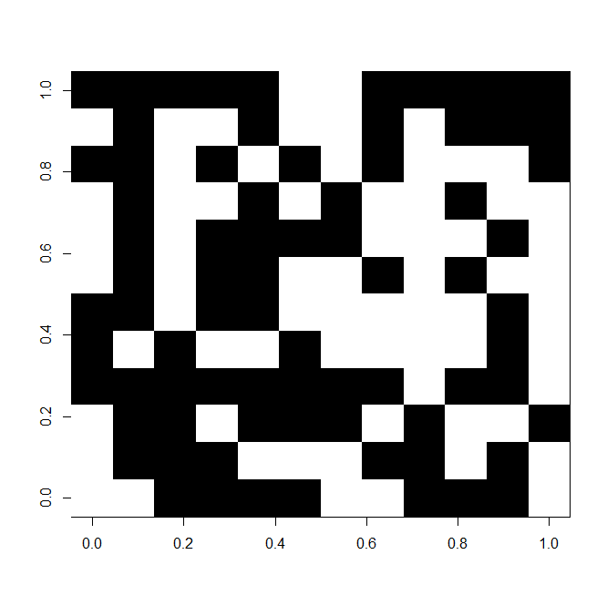
Figure X.1: It's easy to convert a matrix of zeroes and ones to an image using the image command.
This was so easy, you probably want to figure out how to make even more complicated images. First, you can try replacing "white" and "black" with any of the color names on the R color list, to make things a little more interesting. But to create real images, like the ones you might generate using your digital camera, you will need a matrix with a more realistic collection of pixel intensities - not just black pixels that you get from each cell that contains a one, and white pixels from each cell that contains a zero.
Fortunately, it's easy to generate a matrix of random pixel intensities. Here, I picked random numbers between 0 and 1000, then divided each by 1000 to make sure that my resultant values were decimals between 0 and 1:
> mm5 <- apply(mm, c(1,2), function(x) (sample(c(0:1000),1)/1000 ) )
> mm5
[,1] [,2] [,3] [,4] [,5] [,6] [,7] [,8] [,9] [,10] [,11] [,12]
[1,] 0.813 0.874 0.615 0.299 0.105 0.761 0.130 0.524 0.641 0.191 0.633 0.846
[2,] 0.548 0.747 0.463 0.798 0.087 0.396 0.590 0.687 0.720 0.413 0.004 0.919
[3,] 0.167 0.609 0.670 0.354 0.645 0.579 0.926 0.857 0.790 0.552 0.228 0.276
[4,] 0.518 0.500 0.347 0.648 0.225 0.327 0.687 0.888 0.130 0.686 0.020 0.488
[5,] 0.645 0.874 0.245 0.215 0.321 0.878 0.056 0.380 0.532 0.462 0.660 0.446
[6,] 0.089 0.215 0.781 0.447 0.622 0.849 0.288 0.252 0.743 0.657 0.121 0.379
[7,] 0.542 0.370 0.822 0.603 0.996 0.910 0.285 0.189 0.753 0.191 0.853 0.773
[8,] 0.437 0.927 0.292 0.932 0.108 0.085 0.468 0.048 0.821 0.787 0.653 0.989
[9,] 0.680 0.980 0.896 0.239 0.639 0.487 0.567 0.419 0.575 0.613 0.104 0.751
[10,] 0.926 0.639 0.797 0.654 0.782 0.196 0.857 0.866 0.048 0.389 0.327 0.425
[11,] 0.291 0.257 0.268 0.107 0.639 0.557 0.284 0.767 0.288 0.353 0.086 0.441
[12,] 0.868 0.322 0.854 0.731 0.693 0.805 0.356 0.919 0.781 0.287 0.503 0.425

It's also ridiculously easy to generate an image using multiple color schemes. The first line tells R "I want to position the next three images in 1 row and 3 columns."

> par(mfrow=c(1,3))
> image(mm5,col=1:100)
> image(mm5,col=rainbow(7))
> image(mm5,col=heat.colors(10))
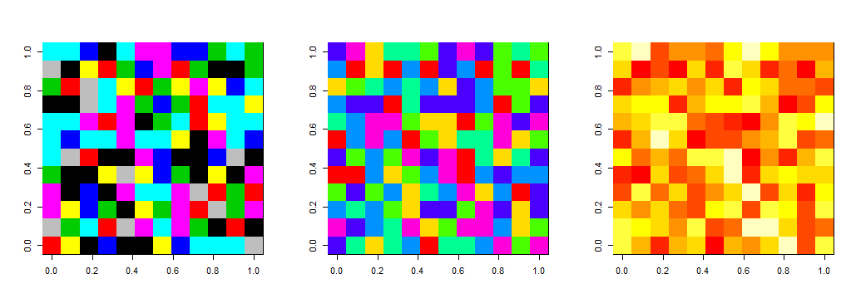
Figure X.2: It's easy to convert a matrix of pixel intensities into an image using different color palettes.

Real-World Example: Using Images to Visualize Status Data
Your company is about to get audited for ISO 9000 compliance, and you are responsible for compiling collections of documents and presenting compliance matrices that will provide an easy visual status report showing everyone's progress. There are 15 managers in the company. You are using a proprietary software program to keep track of the status of all documents, which allows you to dump a report to Excel containing only the fields you need. You want to track how many quarterly reports you have collected from all the managers in the company since the last quarter (Q4) of 2007. The Excel file looks something like this:

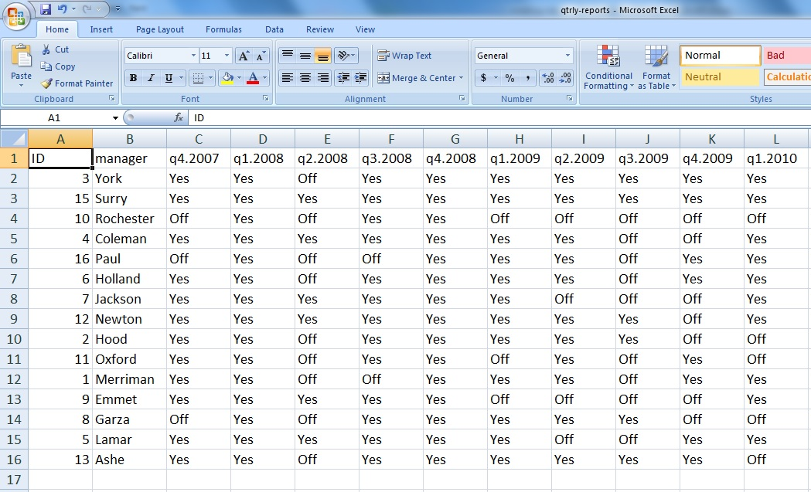
Figure X.2: The first several columns of the qtrly-reports.xls file.
The first thing you might notice is that the cells contain two categorical values: "Yes" and "Off". What?? This doesn't make any sense! Well, this is precisely the kind of weird output you might have to figure out what to do with as an analyst. It turns out that the proprietary software logs "Yes" when the quarterly report document has been successfully submitted to the document management system, and "Off" when the document has not yet been submitted. (Informal chats with the programmers who created the reporting software revealed to you that this is the field in their database that they use to determine whether to turn the "green light" on in their user interface, which is why they chose "Off" instead of "No".)
Now that you have an Excel file, the initial step is to use Excel to convert the file to a CSV (comma-separated values) format that you can import into R. Once you have the CSV file, and you've set your working directory in R using setwd, it's time to make the image. First, load the data:
data <- read.csv("qtrly-reports.csv",header=T)
Since the image command works on a matrix, we have to make sure our data is contained within a matrix. Is it a matrix? Let's check and see:
> str(data)
'data.frame': 15 obs. of 30 variables:
$ ID : int 3 15 10 4 16 6 7 12 2 11 ...
$ manager: Factor w/ 15 levels "Ashe","Coleman",..: 15 14 13 2 12 5 7 10 6 11 ...
$ q4.2007: Factor w/ 2 levels "Off","Yes": 2 2 1 2 1 2 2 2 2 2 ...
$ q1.2008: Factor w/ 1 level "Yes": 1 1 1 1 1 1 1 1 1 1 ...
$ q2.2008: Factor w/ 2 levels "Off","Yes": 1 2 1 2 1 1 2 2 1 1 ...
$ q3.2008: Factor w/ 2 levels "Off","Yes": 2 2 2 2 1 2 2 2 2 2 ...
$ q4.2008: Factor w/ 1 level "Yes": 1 1 1 1 1 1 1 1 1 1 ...
$ q1.2009: Factor w/ 2 levels "Off","Yes": 2 2 1 2 2 2 2 2 2 1 ...
$ q2.2009: Factor w/ 2 levels "Off","Yes": 2 2 1 2 2 2 1 2 2 2 ...
$ q3.2009: Factor w/ 2 levels "Off","Yes": 2 2 1 1 1 1 1 2 2 1 ...
$ q4.2009: Factor w/ 2 levels "Off","Yes": 2 2 1 1 2 2 1 1 1 2 ...
$ q1.2010: Factor w/ 2 levels "Off","Yes": 2 2 1 2 2 2 2 2 1 1 ...
$ q2.2010: Factor w/ 2 levels "Off","Yes": 1 1 2 2 2 2 2 2 1 1 ...
$ q3.2010: Factor w/ 2 levels "Off","Yes": 1 2 2 2 1 2 1 2 1 1 ...
$ q4.2010: Factor w/ 2 levels "Off","Yes": 1 1 1 1 1 1 1 1 1 1 ...
$ q1.2011: Factor w/ 1 level "Yes": 1 1 1 1 1 1 1 1 1 1 ...
$ q2.2011: Factor w/ 2 levels "Off","Yes": 2 2 2 2 2 2 2 1 2 2 ...
$ q3.2011: Factor w/ 1 level "Yes": 1 1 1 1 1 1 1 1 1 1 ...
$ q4.2011: Factor w/ 2 levels "Off","Yes": 2 2 2 2 2 2 2 2 1 2 ...
$ q1.2012: Factor w/ 2 levels "Off","Yes": 2 2 1 2 1 1 2 2 1 1 ...
$ q2.2012: Factor w/ 2 levels "Off","Yes": 1 2 1 2 1 2 2 2 1 1 ...
$ q3.2012: Factor w/ 2 levels "Off","Yes": 2 2 1 2 1 1 2 2 2 2 ...
$ q4.2012: Factor w/ 2 levels "Off","Yes": 2 2 2 2 1 2 2 2 2 2 ...
$ q1.2013: Factor w/ 2 levels "Off","Yes": 2 2 1 2 1 2 2 1 2 1 ...
$ q2.2013: Factor w/ 2 levels "Off","Yes": 2 2 2 2 2 2 2 2 1 2 ...
$ q3.2013: Factor w/ 2 levels "Off","Yes": 2 2 2 2 2 2 2 2 2 2 ...
$ q4.2013: Factor w/ 2 levels "Off","Yes": 2 2 2 2 2 2 2 2 2 1 ...
$ q1.2014: Factor w/ 2 levels "Off","Yes": 2 2 2 2 1 2 2 2 1 2 ...
$ q2.2014: Factor w/ 2 levels "Off","Yes": 2 2 2 2 1 2 2 2 2 1 ...
$ q3.2014: Factor w/ 1 level "Yes": 1 1 1 1 1 1 1 1 1 1 ...

The structure command str tells us that this is a data frame with 15 observations (rows) containing 30 variables (columns). Before we move forward, we have to convert (or "cast") this data frame to a matrix. Let's call it m.data because it's the matrix form of our data:
m.data <- as.matrix(data)

If you check this using the structure command str(m.data) you will find that this is a data structure of type chr [1:15, 1:30] which is a matrix of characters containing rows 1 through 15, and columns 1 through 30. This doesn't actually say it's a matrix, but the bracket notation tells you that indeed it is.

To produce an image, we need to make sure the matrix contains numbers and not words. We tell R to put a zero wherever we see the word "Off", and a one wherever we see the word "Yes":

m.data[m.data == "Off"] <- 0
m.data[m.data == "Yes"] <- 1

If you display the contents of the matrix, you will now see that all of the matrix elements are contained in quotation marks. Even though they are numbers, the data type is a character string. We now need to apply a function over the entire matrix to convert (or "cast") the character string values to integers, which can be plotted. We also want to give the matrix a new name, since we're modifying it significantly, and in the event that we make a mistake we want to be able to go back to the original matrix:

m.data2 <- apply(m.data, c(1,2), function(x) as.integer(x) )

R may tell you that there are "warnings". This is OK. Remember how matrices need to have the same type of data throughout the matrix? Notice that the first two columns of our data contain the employee ID and the name of the manager. When you apply the as.integer function, R knows it can't create a number out of the employee's name, so it will just fill in an NA and tell you there's a problem via a warning. It thinks you have missing data. (You will get a warning every time you have missing data, so as long as you have inspected your original data set and what you see is what you're expecting, there is no need to worry about these warnings.)

Before we create the image, we need to know how many rows and columns there are so we can correctly specify where the numbers are that describe the image. The variable nr will stand for number of rows, and the variable nc will stand for number of columns:

> nr <- dim(m.data2)[1]
> nc <- dim(m.data2)[2]
> nr
[1] 15
> nc
[1] 30

It's important to remember that the first two columns contain data that should not be in the image, with the pixel intensities in the third column through the last column (number 30, which we know since we know the value of nc). Now we can create the image. This time, since we know we'll have to put the image in a presentation to our boss, we want to make it as pretty as possible, with nice titles and axis labels. Fortunately, most of what we need can be done with the image command, but it's long - so each of the arguments to the image command is underlined separately in the statement below. We'll go through each one individually.

image(x=1:nr, y=1:(nc-2), z=m.data2[,3:nc], axes=FALSE, frame.plot=TRUE, col=c("white","black"), main="Document Submission Status", xlab=NA, ylab=NA)

The first three arguments tell image what needs to be contained within the image. We need spots on our horizontal x-axis to contain information for each one of our 15 managers, from 1 to nr (since we know we have one manager per row). We need spots on our vertical y-axis to contain information for each one of our documents. How many documents do we have? Well, since the first two columns contain information we don't want to plot, we know we must have 28 documents, or two less than the total number of columns. We represent this as (nc-2), and read this argument as "the y-axis will go from 1 to 28". The parentheses are there for grouping purposes only. In the third argument, we are specifying the z-axis, which will be the pixel color or intensity. You can think of it as a measure of depth. But since we will have values of z that correspond to each (x,y) pair, we need to provide a matrix of all the different z values we want to plot. The notation m.data2[,3:nc] means "give me all the rows in the matrix called m.data2, but only the columns from 3 to 30." Nothing before the comma means (interestingly enough) "give me everything!" If, hypothetically, we only wanted to plot the first 7 rows, we would write m.data2[1:7,3:nc].

The remaining arguments tell us about what our plot should look like. Setting axes to FALSE means we don't want to label our axes at all... we'll do that later. Setting frame.plot to TRUE draws a thin boxy line around our plot area (try executing this image command without it - the plot kind of looks naked). The col argument specifies what colors should be used in the plot, and main allows us to set our title. By setting xlab and ylab to NA, we make sure that our axes remain unlabeled in our first pass at creating this image.

Here's what it will look like so far:

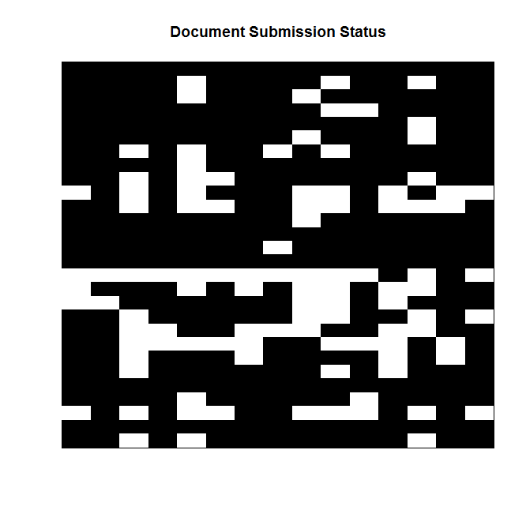
Figure X.3: Plotting categorical data as an image. But now we need to label the axes!

To label the axes, we will use the axis command. First, let's do the x-axis:
axis(1, 1:nr, labels=data$manager, las=2)
Again, each of the arguments is underlined so you can see them better. We are telling the axis command that we want to label axis number 1, which is the x-axis. The x-axis is always referred to as axis number 1. The next argument tells R that we want to label several positions along the x-axis, starting with 1 and going all the way up to 15. But we don't want to label that axis with numbers - instead, we want to list the managers' names. We tell R that we want to use the information contained within the original data frame we called data, and we want the variable name within that data frame that's called manager. (The notation data$manager means "give me the values of the column called manager within the data frame called data".) The last argument just tells R to plot those names rotated 90 degrees to the left. This will ensure that the labels don't get plotted on top of each other. (Try this command without the las=2 and you'll see how bad it looks.) Now, let's add the y axis:
axis(2, 1:(nc-2), labels=colnames(m.data2[,3:nc]), las=2)
We are telling the axis command that we want to label axis number 2, which is the y-axis. The y-axis is always referred to as axis number 2. The next argument tells R that we want to label several positions along the y-axis, starting with 1 and going all the way up to 28 (two less than the total number of columns). But we don't want to label that axis with numbers - instead, we want to list which quarter and year the quarterly report we're looking for comes from. Fortunately, this information is contained in our variable names, so we can use that. We tell R that we want to use the actual column names of the matrix called m.data2, but we only want to use the names from columns 3 through 30. Because a matrix is described, in general, as matrixname[rows,columns] we have to put that floating comma in our call to axis to make sure R knows we are really talking about column names, and not row names. Here's what our plot looks like now:
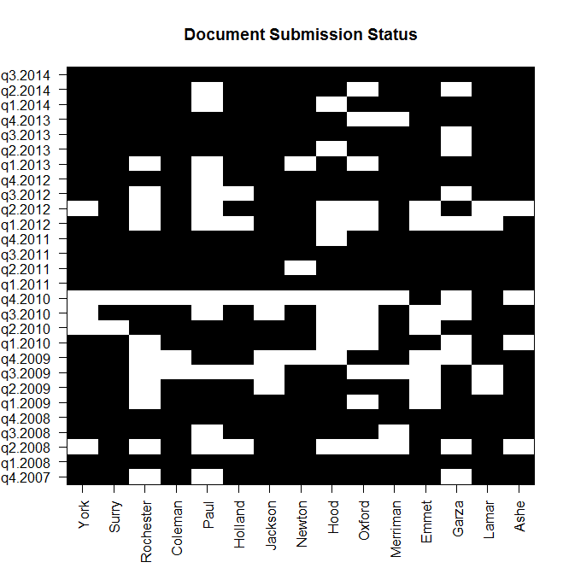
Figure X.4: Plotting categorical data as an image, then making nice informative axis labels.
Conclusions
If you were a manager, how would you interpret the image you produced in Figure X.4? The first thing that jumps out at me is that nearly the entire q4.2010 row is white. We are missing a lot of quarterly reports from the fall of 2010. Is there a reason for this? We should check into it. We have all of our reports submitted from the first quarter of 2011, which is good. In general, it looks like most managers have done a good job compiling these documents so far and getting them into the document management system. I don't see any columns that are completely white, so all managers know that they are supposed to find these reports and store them in the system. Everyone appears to be working on it.

Get Points!
To demonstrate the knowledge that you have gained from this exercise, find or create a new data source, generate an image, and interpret the results (if it makes sense to do so). Be sure to keep a listing of all of your code (and the data files you used) to store in your GitHub portfolio.

Now What?
You now have the background and experience to try exercises like:
- Using Multidimensional Arrays for Animations and Hyperspectral Imaging

